**CS341 - DESIGN PROJECT REPORT**

**ON**

**GLOVETALK**

***Submitted By***

R V VIVEK VISWAM, ROHIT K VINOD, SHASHWATH R PAI, VISHAL R VIPIN

**S5 CS** γ



Department of Computer Science & Engineering RAJAGIRI SCHOOL OF ENGINEERING & TECHNOLOGY

Affiliated to APJ Abdul Kalam Technological University November, 2020

**GloveTalk Design Project Report**

**Rajagiri School of Engineering & Technology** RAJAGIRI VALLEY, KAKKANAD, COCHIN – 682 039

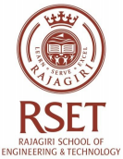

**Certificate**

*Certified that this is a Bonafide Record of the work done by* ***R V VIVEK VISWAM, ROHIT K VINOD, SHASWATH R PAI, VISHAL R VIPIN*** *in the* **DESIGN PROJECT** *during the* ***FIFTH*** *semester in year 2020 at Rajagiri School of Engineering & Technology, Kakkanad, Kochi.*

Dr. Dhanya P. M.

Project-In-Charge Head of the Department

Uni. Reg Nos. : RET18CS152, RET18CS147, RET18CS167, RET18CS194 Branch : COMPUTER SCIENCE & ENGINEERING

Semester : S5

Dept. of CSE, RSET Page 2

**GloveTalk Design Project Report**

**ACKNOWLEDGEMENT**

The project that we embarked on posed several challenges pertaining to knowledge, skill and even material availability. This project would have been far from complete without the invaluable guidance and support from several invisible hands that worked on it tirelessly, The Management, The Principal, The HOD, our course incharge Dr.Varghese Paul and our beloved class teacher Mr. Sandy Joseph. It is to those hands we would like to thank here.

We would like to specially thank Mr.Sandy Joseph and Dr. Varghese Paul for providing us with the opportunity to work on this challenging project and for having trust in us.

Dept. of CSE, RSET Page 3

**GloveTalk Design Project Report** Dept. of CSE, RSET Page 4

**GloveTalk Design Project Report**

**ABSTRACT**

Around the globe, for mute, interpersonal communication is almost impossible without an interpreter or if the other person is unfamiliar with American Sign Language(ASL). What if the person is unfortunate with few less fingers to even show the Standard Sign Language (ASL)? Even using an interpreter would be ridiculously hard. This confines the person to a very small community familiar to him/her, closing the door to the outside world. Project GloveTalk, consists of a glove embedded with sensors and an android app to interact with anyone without any hindrance. GloveTalk eliminates the need for an interpreter or a Standard Sign language for communication, by letting the user create own sign language and output as voice through the GloveTalk android app. This enables even people with less fingers to communicate without the need of an interpreter, explore and communicate to the outside world as any other person.

Dept. of CSE, RSET Page 5

**GloveTalk Design Project Report**

**Table of Contents**

1. Introduction 9 2. Design Project – Phase 1: Study Phase 9 2.1 Universal Serial Bus (USB) - R V Vivek Viswam 9 2.2 Arduino - Rohit K Vinod 9 2.3 Bluetooth Headphone - Shashwath R Pai 9 2.4 MRI - Vishal R Vipin 10 3. Design Project - Phase 2: Problems & Solutions 11 3.1 Problem Identification & Definition 11 3.2 List of alternate ideas/solutions 11 3.3 Literature Survey 12 3.4 Design and Implementation Constraints 12 3.5 Solution Prototype 13 Design Project - Phase 3: Design Models & Documentation 14 4. Problem Statement 15 5. Project Objectives 15 6. System Overview & Requirement Specification 15 6.1 System Overview 15 6.2 Functional & Non-Functional Requirements 16 6.3 List of Actors 16 6.4 Use Case Diagram 17 7 Analysis and Design Models 18 7.1 Sequence Diagrams 18 8 Limitations 19 9 Conclusion 19 10 Bibliography 20 11 Appendix 21

Dept. of CSE, RSET Page 6

**GloveTalk Design Project Report** List of Figures

Fig.1 GloveTalk Android application & GloveTalk glove

Fig.2 High level system architecture

Fig.3 Use case diagram

Fig.4 Sequence diagram

Fig.5 GloveTalk circuit diagram

Dept. of CSE, RSET Page 7

**GloveTalk Design Project Report** List of Abbreviations

USB - Universal Serial Bus

MRI - Magnetic Resonance Imaging

NLP - Natural Language Processing

ASL - American Sign Language

Dept. of CSE, RSET Page 8

**GloveTalk Design Project Report**

**1. Introduction**

**Course Objecves**

● To understand the engineering aspects of design with reference to simple products ● To foster innovaon in design of products, processes or systems

● To develop design that add value to products and solve technical problems **Expected outcome**

The students will be able to

● Think innovavely on the development of components, products, processes or technologies in the engineering field

● Apply knowledge gained in solving real life engineering problems

**2. Design Project – Phase 1: Study Phase**

**2.1 UNIVERSAL SERIAL BUS - R V VIVEK VISWAM**

Before the invention of USB, computer manufacturers and users faced the problem of multitude connectors to peripheral devices. In 1994 computer giants Compaq, DEC, IBM, Intel, Microsoft, NEC, Nortel came together to solve this problem. The solution was USB, developed by Ajay Bhatt in 1995 while working at Intel. USB came with a lot of improvement in data transmission rates and was a simple solution with easy implementation, which led to quick adoption across the globe.

**2.2 ARDUINO - ROHIT K VINOD**

Arduino is an open-source hardware and software company, project and user community that designs and manufactures single-board microcontrollers and microcontroller kits for building digital devices.

**2.3 BLUETOOTH HEADPHONE - SHASWATH R PAI**

Bluetooth headphones enable wireless connectivity between the headphone and other devices such as mobile phones, television, computer etc to listen to audio transmitted from the other device. Before its invention devices used analog cables for connectivity.

Dept. of CSE, RSET Page 9

**GloveTalk Design Project Report 2.4 MRI - VISHAL R VIPIN**

Magnetic resonance imaging (MRI) is a medical imaging technique used in radiology to form pictures of the anatomy and the physiological processes of the body. MRI scanners use strong magnetic fields, magnetic field gradients, and radio waves to generate images of the organs in the body.

Dept. of CSE, RSET Page 10

**GloveTalk Design Project Report**

**3. Design Project - Phase 2: Problems & Solutions**

Mute people use ASL or use an interpreter companion to communicate. But people with less than 5 fingers face severe difficulty in expressing their feelings as ASL requires all 5 fingers. Even for mute people with all fingers are forced to use a human interpreter to communicate with a person untrained in ASL.

Since the project was intended to eliminate dependency on companion interpreter and Standard sign language, the obvious solution was technology assisted speech. As almost all people own a mobile device, which contains speakers and internet connectivity,it was chosen as a major part of the project. And gesture interpretation required determination of bend on users fingers, therefore the gesture interpreter was chosen to be a glove embedded with flex sensors.

**3.1 Problem Identification & Definition**

For the project selection, our team was determined to develop a technology to assist disabled people. And the first problem that our team identified was voice for mute people. On further investigation, we came across a disturbing fact, that people with fewer than 5 fingers were among the severely suffering ones in the mute community. Since our team found the aforementioned problem to be a serious issue, we decided to work on it without a second thought.

**3.2 List of alternate ideas/solutions**

After we had fixed our problem and goal, a few ideas came up for consideration.

Implementing a gesture to speech converter for people without any fingers, by developing a wrist worn device fitted with an accelerometer only, was one of them. But training a gesture model (ML model) only with wrist movement of different people has a very high chance of incorrect prediction. Therefore it would have required a significant amount of time for its development and dataset preparation.

Another solution was to use existing smart watches to collect accelerometer data instead of developing a new device. But this solution required the user to possess a smart watch, since poorer sections of people were in purview, the solution was deemed to be impractical for large scale implementation.

A practical solution that came up was to use flex sensors and other electronic items, android phone and a server to host gesture and NLP models, to convert sensor data to speech. After analyzing the cost and time availability, we chose this as our solution to the problem.

Dept. of CSE, RSET Page 11

**GloveTalk Design Project Report**

**3.3 Literature Survey**

On researching and analysing online resources, we found similar solutions, to interpret gestures and convert to speech, but all of the solutions were applicable only to people with all 5 fingers. Also such solutions implemented ASL or similar standard sign languages, thereby it deprived mute people with fewer fingers to use them.

**3.4 Design and Implementation Constraints**

A complete solution to the problem required the system to be functional even in remote locations with no internet connection. Such solutions required language model to be available offline on the user's Android device. Also those solutions would have consumed large amounts of space for language models and required expertise in model compression techniques for a proper implementation. But a simple model solution could have been implemented, this would have increased the project complexity, which was beyond the scope of the course.

Dept. of CSE, RSET Page 12

**GloveTalk Design Project Report**

**3.5 Solution Prototype**

The solution consists of

1. An android application

2. Glove embedded with sensors

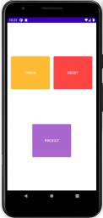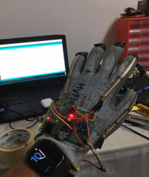

**fig.1 GloveTalk Android App and GloveTalk Gloves**

Dept. of CSE, RSET Page 13

**GloveTalk Design Project Report Design Project - Phase 3: Design Models & Documentation**

Dept. of CSE, RSET Page 14

**GloveTalk Design Project Report 4. Problem Statement**

Mute people use ASL or use an interpreter companion to communicate. But people with less than 5 fingers face severe difficulty in expressing their feelings as ASL requires all 5 fingers. Even for mute people with all fingers are forced to use a human interpreter to communicate with an untrained (ASL) person.

**5. Project Objectives**

● A simple device operable by a common man,

● low resource consuming, soware and hardware device,

● workable even at remote locaons

to convert user intenons to speech

With a prime objective to eliminate dependency on a companion or a Standard Sign Language (ASL) .

**6. System Overview & Requirement Specification**

**6.1 System Overview**

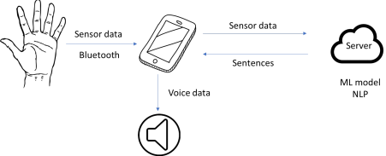fig.2 System overview

Dept. of CSE, RSET Page 15

**GloveTalk Design Project Report 6.2 Functional & Non-Functional Requirements**

|  |  |  |  |
| --- | --- | --- | --- |
| **Req.**  **No.** | **Requirements** | **Requiremen t Type**  **(Funconal or**  **Non-Funco nal)** | **Priority or**  **Importance (High,**  **Medium,**  **Low)** |
| 1 | The product should assist a mute person communicate anywhere at anyme without the need of a human translator | Funconal | High |
| 2 | The product must be able to remove a standardized language and let any mute person create their own language . | Funconal | High |
| 3 | The product should be able to assist in translang gestures shown by a mute person less in the number of fingers. | Funconal | Medium |

**6.3 List of Actors**

|  |  |
| --- | --- |
| **Actor** | **Descripon** |
| User | The mute person using the device |
| GloveTalk Glove | Glove embedded with sensors to interpret gesture |
| Server | That hosts Gesture and NLP models to convert sensor data to English sentences |

Dept. of CSE, RSET Page 16

**GloveTalk Design Project Report**

**6.4 Use Case Diagram**

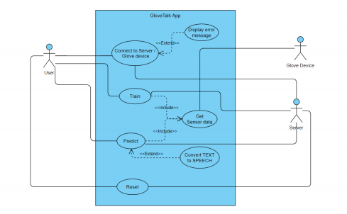fig.3 Use case diagram

Dept. of CSE, RSET Page 17

**GloveTalk Design Project Report**

**7 Analysis and Design Models**

**7.1 Sequence Diagrams**

fig.4 Sequence diagram

Dept. of CSE, RSET Page 18

**GloveTalk Design Project Report**

**8 Limitations**

1. The present design requires an active internet connection for its functioning. 2. Also the design was implemented in English language as voice output, i.e it doesn’t support regional languages.

**9 Conclusion**

The implemented design prototype was able to successfully solve the problem, to a degree such that it could be released as a product with minor improvements to the NLP model. But it lacked the ability to function in remote locations without internet connection. The aforementioned limitation could be solved to a certain degree with sufficient time for its development. But a complete solution requires expertise in NLP model compression techniques, as NLP models could consume a lot of memory in mobile devices, which are beyond the scope of this course. An implementation in regional language requires vast amounts of datasets to train NLP models in regional languages, which are hard to get in the present scenario. But, overall implementation was able to solve the problem in English in online mode successfully.

Dept. of CSE, RSET Page 19

**GloveTalk Design Project Report Bibliography**

Operating System Concepts - Avi Silberschatz, Peter Baer Galvin, Greg Gagne Dept. of CSE, RSET Page 20

**GloveTalk Design Project Report Appendix**

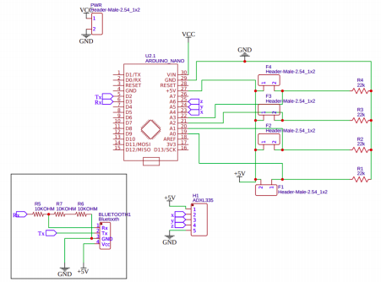Fig.5 GloveTalk Glove circuit diagram

Dept. of CSE, RSET Page 21